Spreadsheet Report Designer (diagram)

Author: $Author

Publisher: $Publisher

Date: $date
The Spreadsheet Report Designer diagram provides a convenient way to prepare simple structure of Microsoft Excel document template (XLSX), as shown in the following steps.

Create your Spreadsheet Report Designer diagram
Create a new Spreadsheet Report Designer diagram in the Report Designer Diagrams category.
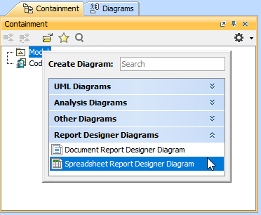
You will get the empty Spreadsheet Report Designer diagram.
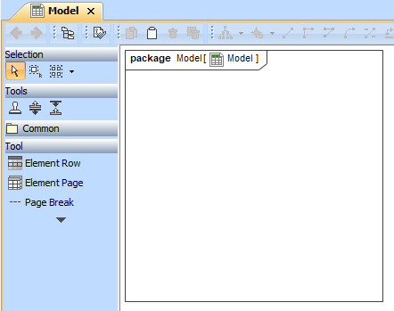

Start with Element Page
Click the Element Page button on the toolbar and drop it on the diagram. The Element Page dialog will be opened.
Then, select the element type and enter row as well as column numbers for creating a blank table for entering content of each sheet in \#forpage directive, the created blank table would be created in the \#forpage directive, for printing all selected elements type in your project per each sheet.

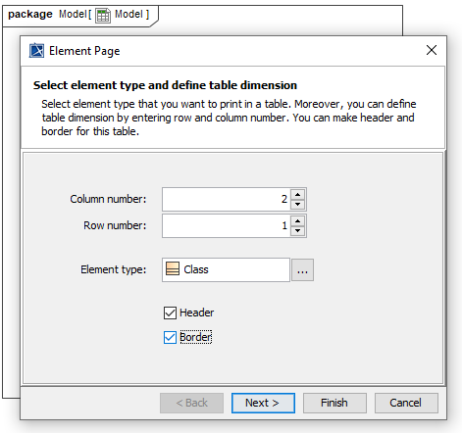

Directly manipulate table in the Element Page dialog by double click the table cell, you could enter any text or Velocity code. You could click “.”+Spacebar to open the available property guide dialog, click it to change the page to Helper Tool. You could select the suggested item, it would fulfill property or helper tool at the cursor position.

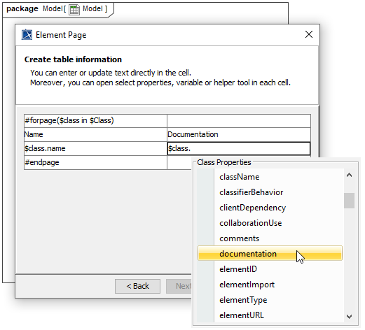
Click Finish button, the Element Page element would be created on your diagram. If you would like to update the content in the table, you could double click the Element Page, its Element Page dialog would be opened. If you are back to update row and column table in the first step, the table would be reset.
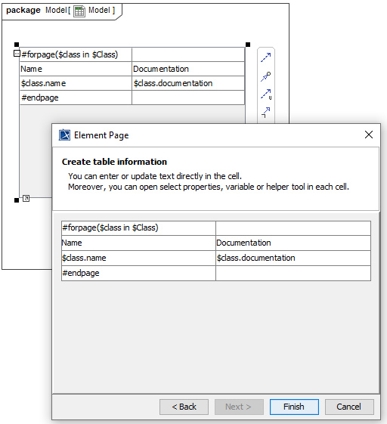

Start new sheet with Page Break
Click the Page Break button on the toolbar and drop it on the diagram. A new sheet would be start after this Page Break.
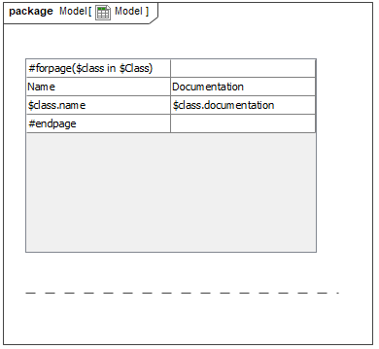

Print element data in table
Click the Element Row button on the toolbar and drop it on the diagram. The Element Row dialog would be opened. Select element type and enter row as well as column numbers, for creating a blank table for printing element data in each row of the table, in \#forrow directive.
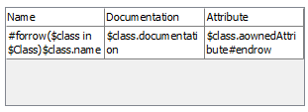
Moreover, you do not need to enter element type, you could enter only row and column numbers, the blank table would be created, or enter any only function is allowed. The Table row and column would be collected and printed in a same sheet.
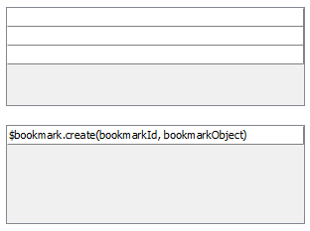

Generate PPTX template from the Spreadsheet Report Designer diagram
Now you have a complete Spreadsheet report designer.
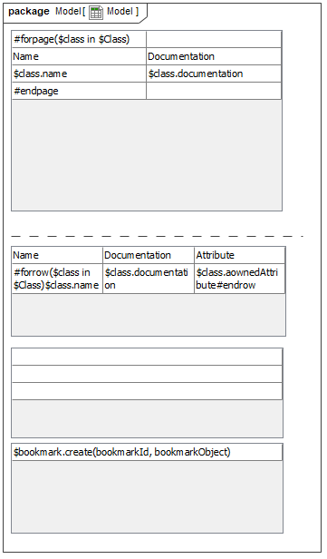
You can start to generate the template by right-clicking Spreadsheet Report Designer in the Containment tree and selecting Generate Template > XLSX Template.
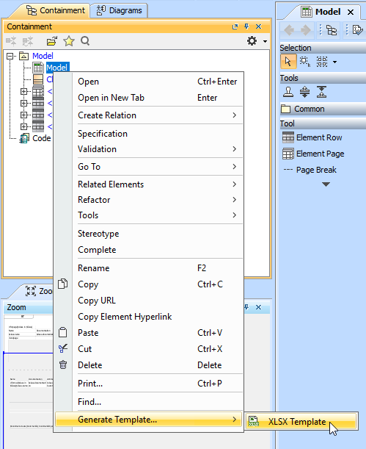

Here is the complete template you can refine more code logic and apply font styles in Microsoft Excel.


